**OS ASSIGNMENT 2:**

# Task1:

#include<iostream>

#include<sys/wait.h>

#include<unistd.h>

#include<stdlib.h>

using namespace std;

int main()

{

pid_t pid=fork();

if(pid<0)

cout<<"Error\n";

else if(pid==0)

{

cout<<"Parent ID = "<<getppid()<<endl;

cout<<"Child ID = "<<getpid()<<endl;

}

else

{

sleep(10);

cout<<"Child termination"<<endl;

}

}

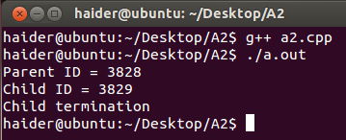

# Task2:

#include<iostream>

#include<sys/wait.h>

using namespace std;

int main()

{

pid_t pid=fork();

if(pid==0)

{

cout<<endl<<"I am Child my ID is= "<<getpid()<<" and my Parent ID is= "<<getppid()<<endl;

}

else if(pid>0)

{

wait(NULL);

cout<<endl<<"I am Parent my ID is= "<<getppid()<<" and my Child ID is= "<<getpid()<<endl;

}

else

{

cout<<"Child process is not being created"<<endl;

}

}

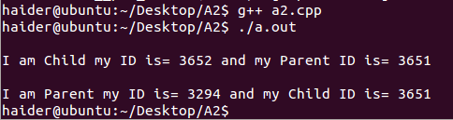

# Task3:

#include<iostream>

#include<sys/wait.h>

#include<unistd.h>

#include<stdlib.h>

using namespace std;

int main()

{

int num;

cout<<"\nEnter a number : ";

cin>>num;

pid_t pid=fork();

if(pid<0)

cout<<"Error\n";

else if(pid==0)

{

int temp=num;

int total=0;

int mod;

while(temp!=0)

{

mod=temp%10;

total=total*10+mod;

temp/=10;

}

if(total==num)

cout<<"The number is palindrome\n";

else

cout<<"The number is not palindrome\n";

}

else

{

wait(NULL);

cout<<"Child termination completed"<<endl;

exit(1);

}

}

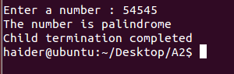

# Task4:

#include<iostream>

#include<sys/wait.h>

#include<unistd.h>

#include<stdlib.h>

using namespace std;

int main()

{

int num;

cout<<"\nEnter a number : ";

cin>>num;

pid_t pid;

for(int i=0;i<num;i++)

{

pid=fork();

if(pid<0)

cout<<"Error\n";

else if(pid==0)

{

cout<<"Child process ID = "<<getpid()<<endl;

}

else

{

wait(NULL);

cout<<"Child termination completed"<<endl;

exit(1);

}

}

}

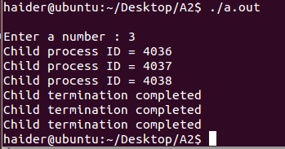

# Task5:

#include<iostream>

#include<sys/wait.h>

#include<unistd.h>

#include<stdlib.h>

using namespace std;

int main()

{

char f1[10],f2[10];

pid_t pid=fork();

if(pid<0)

{

cout<<"Error\n";

exit(1);

}

else if(pid==0)

{

cout<<"Enter 1st file name : ";

cin>>f1;

cout<<"Enter 2nd file name : ";

cin>>f2;

execlp("echo","echo",f1,f2,NULL);

exit(1);

}

else

{

wait(NULL);

cout<<"Child termination completed"<<endl;

exit(1);

}

}

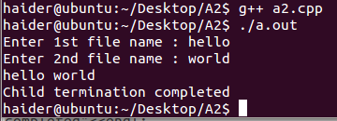

# Task6:

#include<iostream>

#include<sys/wait.h>

#include<unistd.h>

#include<stdlib.h>

using namespace std;

int main()

{

int fd1[2];

int fd2[2];

pid_t pid;

int num,total=1;

cout<<"Enter a num : ";

cin>>num;

int ret;

ret=pipe(fd1);

if(ret==-1)

{

cout<<"Error\n";

exit(1);

}

ret=pipe(fd2);

if(ret==-1)

{

cout<<"Error\n";

exit(1);

}

pid=fork();

if(pid<0)

{

cout<<"Error\n";

exit(1);

}

else if(pid==0)

{

cout<<"This is child process\n";

close(fd1[0]);

cout<<"\nChild calculating factorial\n";

for(int i=1;i<=num;i++)

total*=i;

write(fd1[1],&total,10);

close(fd2[0]);

cout<<"\nChild calculating sqaure\n";

total=num*num;

write(fd2[1],&total,10);

}

else

{

cout<<"This is parent process\n";

close(fd1[1]);

read(fd1[0],&total,10);

cout<<"\nParent reading factorial\n";

cout<<"The factorial of num = "<<total<<endl;

close(fd2[1]);

read(fd2[0],&total,10);

cout<<"Parent reading square\n";

cout<<"The square of num = "<<total<<endl;

}

}

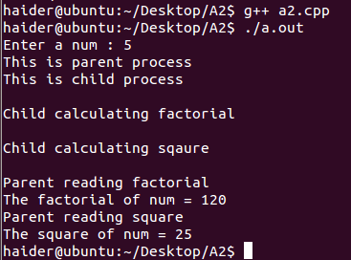

# Task7:

#include<iostream>

#include<sys/wait.h>

#include<unistd.h>

#include<stdlib.h>

using namespace std;

int main()

{

pid_t pid;

int num;

cout<<"Enter a num to create children : ";

cin>>num;

for(int i=0;i<num;i++)

{

pid=fork();

if(pid<0)

{

cout<<"Error\n";

exit(1);

}

else if(pid==0)

{

cout<<"\nGroup_ID = "<<getpgid(pid)<<" and Child PID = "<<getpid()<<endl;

}

else

setpgrp();

}

for(int i=0;i<num;i++)

wait(NULL);

}

